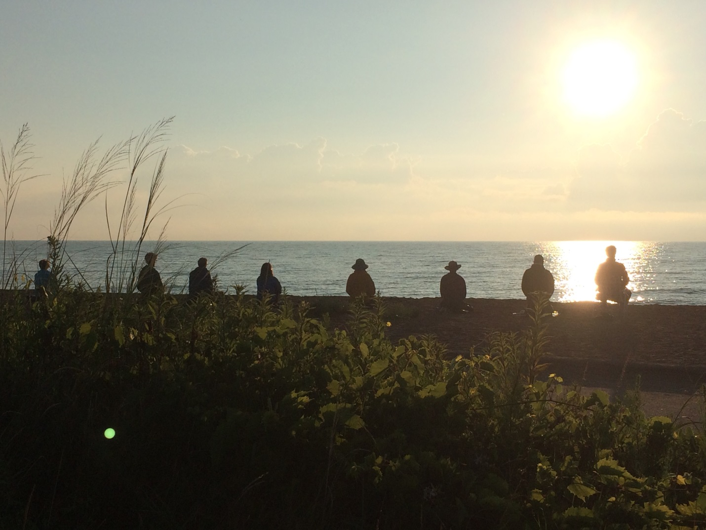
Join Us for Our Third Annual
Three-Day Camping Sesshin
June 20 – 23, 2019
This three-day sesshin will combine traditional Zen forms and Dharma teachings within the natural setting provided by Illinois Beach State Park. Sesshin will take place in a sheltered, open-air environment, and opportunities will be available for tent camping for overnight participants. Daily Dharma talks, discussions, communal meals and nature walks will be offered by Eishin Nancy Easton and Gyoshin Laurel Ross, and other senior students under the guidance of Taigen Dan Leighton. This sesshin offers an opportunity to bring your practice to an encounter with the natural world, without venturing far from home.
It is possible to sign up for one, two, or all three days (participants will arrive Thursday evening, June 20 to camp overnight for Friday sesshin day; Sunday is a half-day to allow for clean-up). Breakfast, lunch, and dinner will be provided Friday and Saturday; breakfast and lunch on Sunday. Some sesshin experience is required for this event, and you must register by June 10, 2019—registration forms are available online or at ADZG. Registration for camping sesshin is limited. For more information, or to register, please speak to Eishin or Gyoshin, or send an email to: info@ancientdragon.org.

